Les 6

Led branden via programma

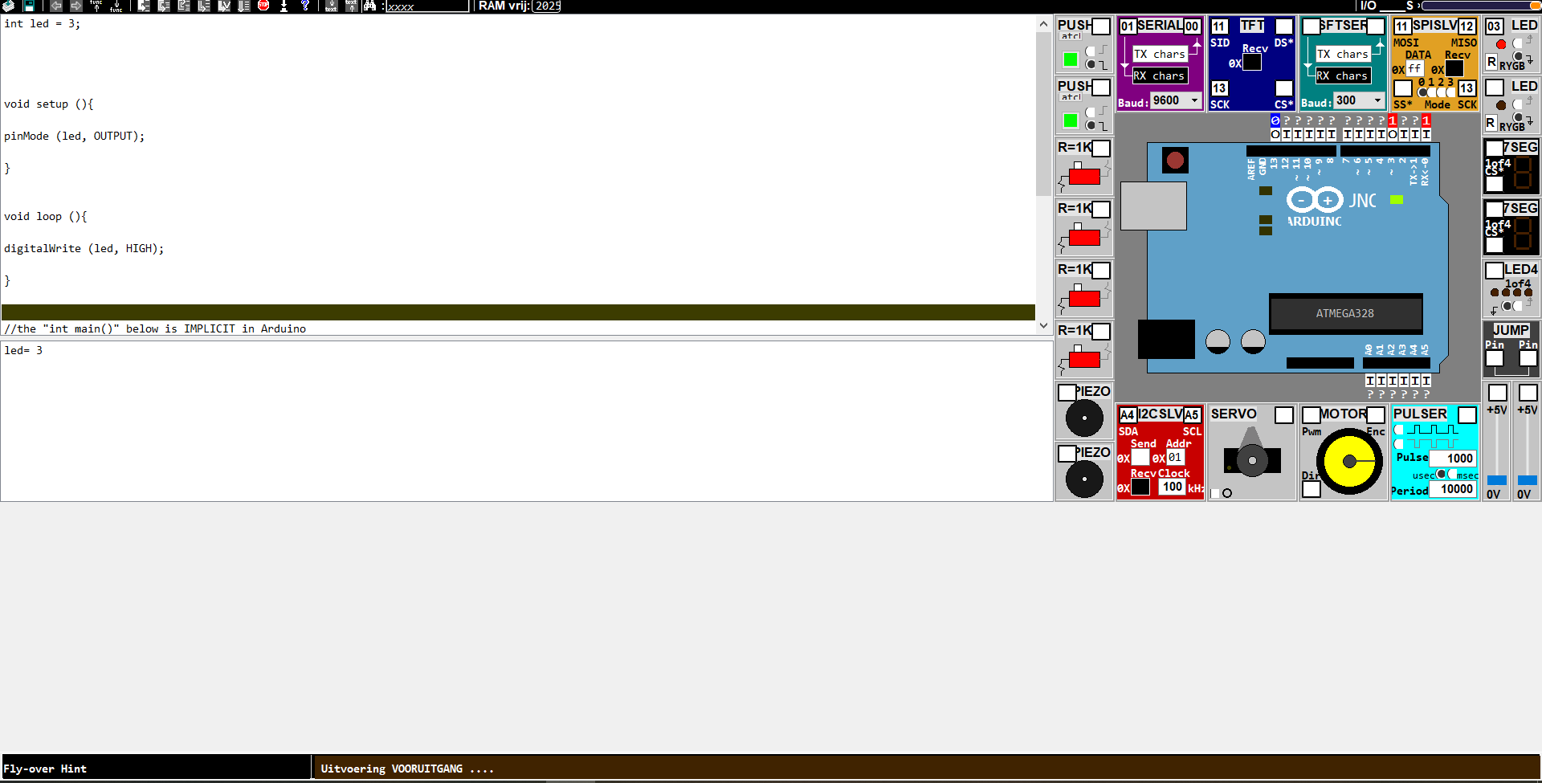

int led = 3;

void setup (){

pinMode (led, OUTPUT);

}

void loop (){

digitalWrite (led, HIGH);

}